**VFW POST 5350**

**VOICE OF DEMOCRACY AWARDS**

**&**

**PATRIOT’S PEN AWARDS**

**JANUARY 24th, 2019; 7PM**

**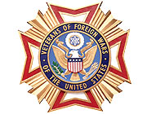*Honoring the Accomplishments of***

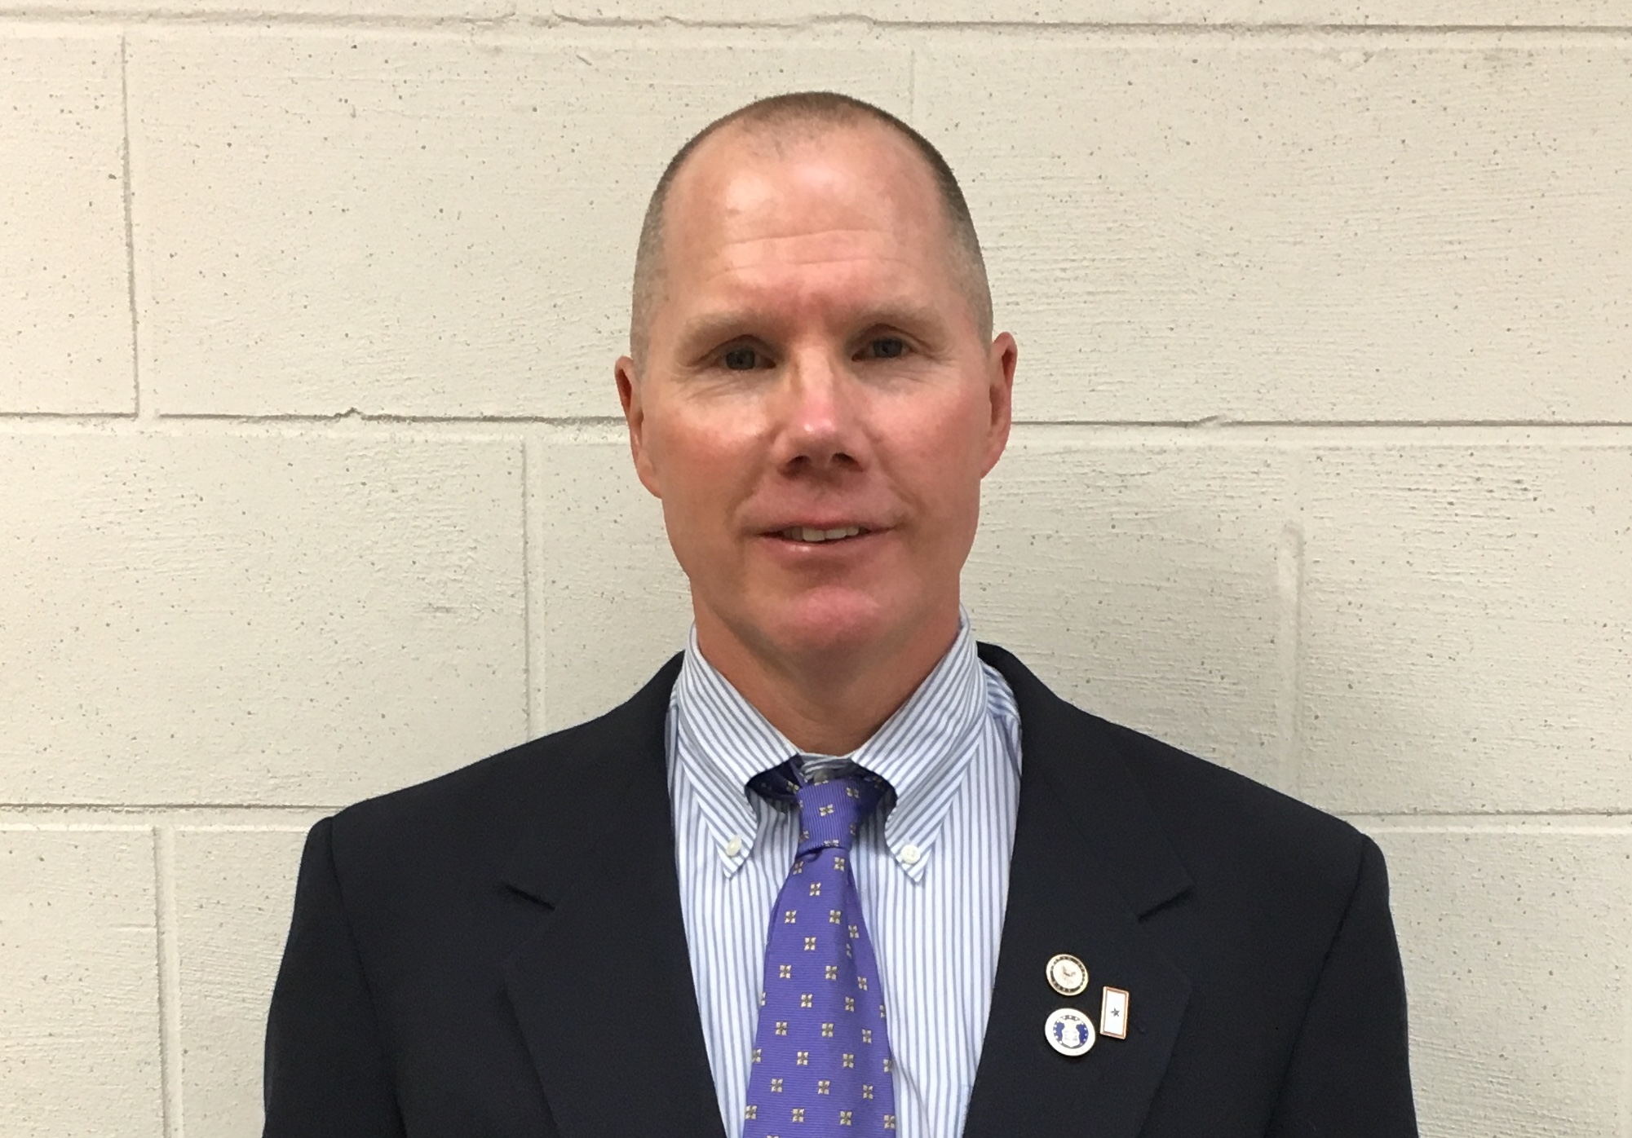

Mr. Korey Williams, VFW Post 5350 and District One Teacher of the Year 2019

***MCj04298990000[1]***

***The Students of Westhampton Beach; Hampton Bays***

***&***

***Raynor Country Day School***

***Thursday, January 24th, 2019***

Opening The Pledge of Allegiance

The Star Spangled Banner- Soloist TBA

Hampton Bays High School

Remarks Commander William Hughes

Veterans Introductions WW II Albert Vicurilli

Korean War Mr. Peter Cuthbert

Vietnam War Mr. Phil Keith

Iraq Mr. Daniel Stebbins

Afghanistan Ms. Regina Marengo

Presenters:

Mr. Korey Williams- Westhampton Beach Schools

Mr. William Hughes- Hampton Bays Schools

Voice of Democracy Awards- Westhampton Beach High School

Pierce Rosen-Keith

Voice of Democracy Awards- Hampton Bays High School

Ian Hubbard

Skye McMorris

Ava Aube

Patriot’s Pen Awards- Westhampton Beach Middle School

Donye Hope

Haley Stoehr

Patriot’s Pen Awards- Hampton Bays Middle School

Emily Barnes (2nd. place in District One)

Elijah Amos

Marilyn Ramos

Patriot’s Pen Awards- Raynor County Day School

Camdyn Glover

Refreshments and Camaraderie